**Sapui5 Navigation between views:-**

Since SAPUI5 application is single page application we need a root control which can consume view inside it.'App' control is the one of the SAPUI5's root control. Any SAPUI5 need to be added to this 'App' control before displaying i.e. have already seen how to create application with more than two views now we will see how to navigate between those views.

[Example](http://www.fioritutorials.com/sapui5-practical-navigation-and-routing/sapui5-navigation-between-views.html#collapseThree)

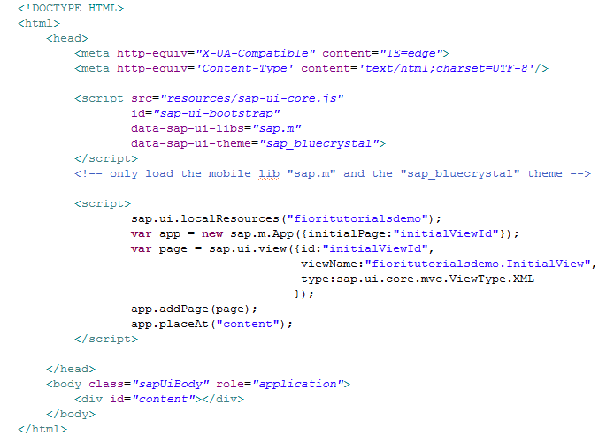

var app = new sap.m.App({initialPage:"initialViewId"});   
Here we have initialized the 'App' control.

initialPage:"initialViewId ---> Means when 'App' controls loads it will display 'initialViewId' page.

app.addPage(page); ---> 'initialViewId' view has beed added to 'App'.

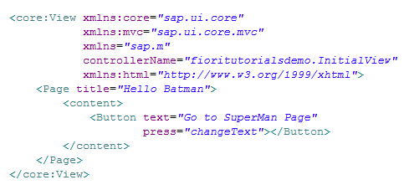

This is initial view. By clicking this button we are calling changeText fuction which then navigate to other view.

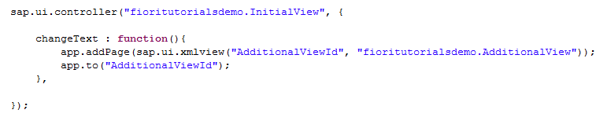

In 'changeText' function we are first adding the second view.   
Then using app.to("AdditionalViewId"); ---> Navigating to second view.

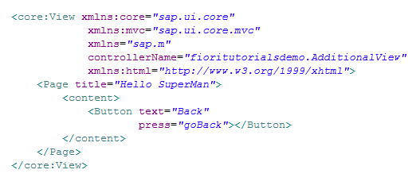

This is second view. Here also we have defined a button which will call 'goBack' fuction which navigate back to first view.

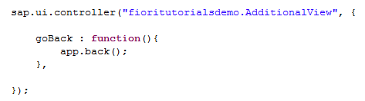

Here we can see that in 'goBack' function we have not added first view because the first view is already added to 'App' control.   
App.back() ---> will navigate to previously visited view.

[Browser Output](http://www.fioritutorials.com/sapui5-practical-navigation-and-routing/sapui5-navigation-between-views.html#collapseFour)

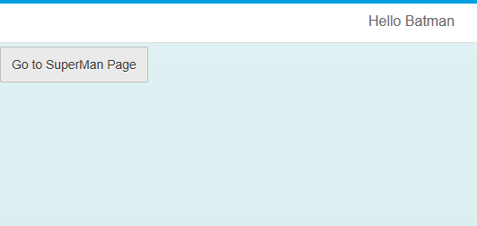

This is the initial display. By pressing this button it will loads second view.

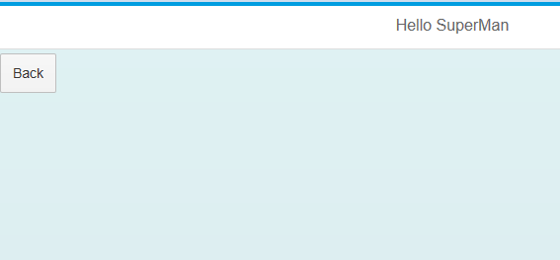

By pressing this button it will navigate back to previous view.

**Sapui5 application simple routing:-**

In this practical we will see how to navigate from one view to another view using routing concept. Let's start with simple Full Screen Routing.

[Example](http://www.fioritutorials.com/sapui5-practical-navigation-and-routing/sapui5-full-screen-simple-routing.html#collapseThree)

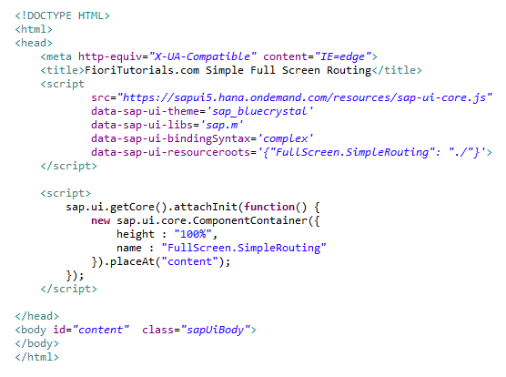

This is index.html. The ComponentContainer will initiates the component.js file.

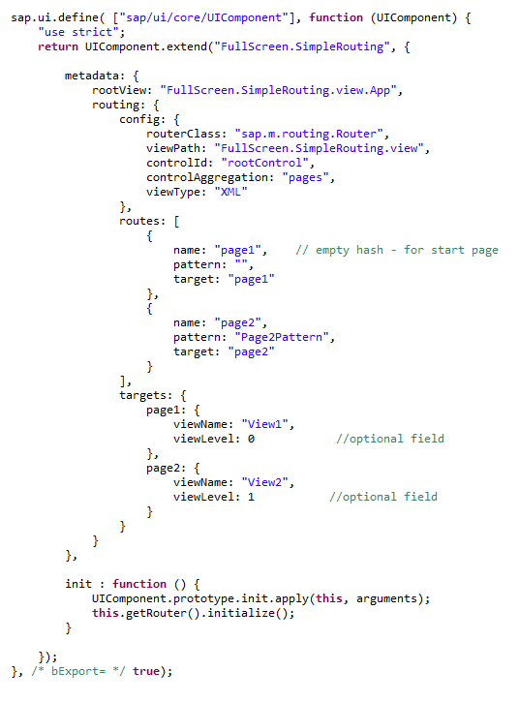

This is component.js file. Routing logic has been written in the metadata section.

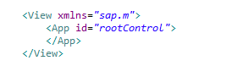

This is app view which is the root view of our application.

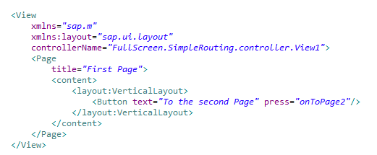

This is the first view. A button has been taken for navigate to second page.

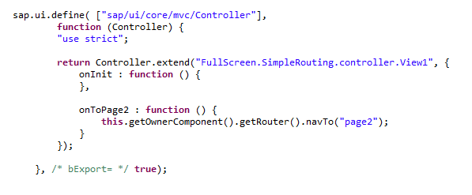

This is the controller of first view. Routing logic has been written in the 'onToPage2' function.

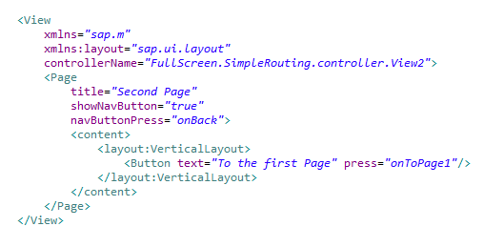

This is the second view. A button has been taken for navigate to first page.

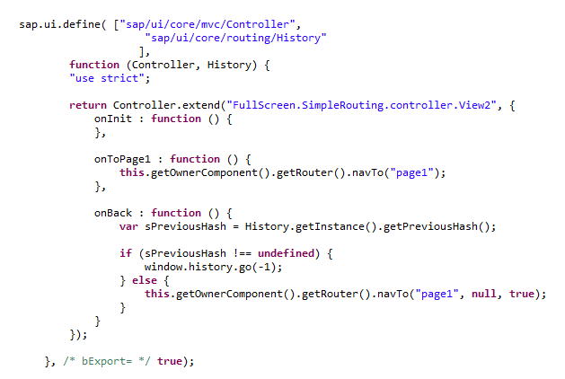

This is the controller of second view.Routing logic has been written in 'onNavBack' function.   
Here it will first check if the history of previous route is exist if not then by default it will navigate to 'page1' view.

[Browser Output](http://www.fioritutorials.com/sapui5-practical-navigation-and-routing/sapui5-full-screen-simple-routing.html#collapseFour)

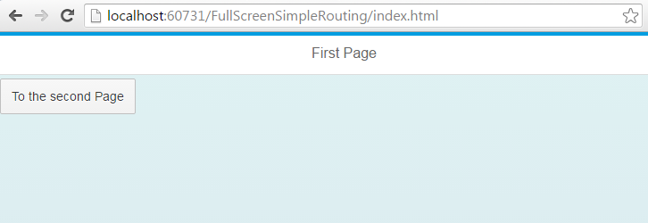

This is the browser output when it initially load the application on browser. As you can see there is not pattern in the URL area. When you click this button it will navigate to second view.

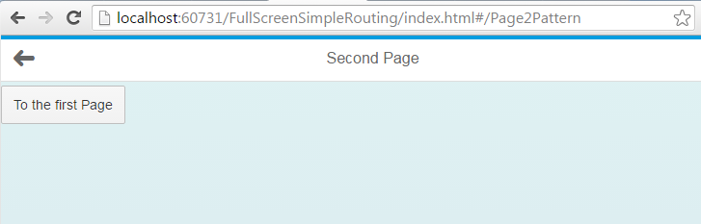

This is the second view on browser. As you can see the URL area a pattern 'Page2Pattern' is displaying. Now if you click Navigation button or 'To the first page' button it will navigate to first page.

**Routing With Link:-**

In this practical we will see how to navigate by clicking the 'Link' using routing concept. In simple HTML application we have link tag and to navigate we just need to pass URL of target page in the href property. But in SAPUI5 it's little different. Let's see how we can achieve this in SAPUI5.

[Example](http://www.fioritutorials.com/sapui5-practical-navigation-and-routing/sapui5-routing-with-link.html#collapseThree)

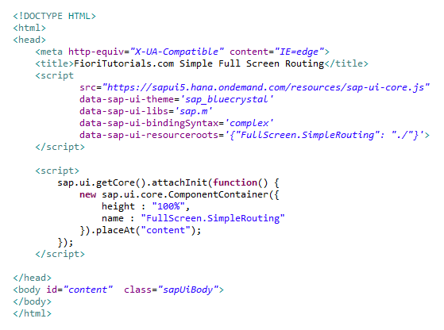

This is index.html. The ComponentContainer will initiates the component.js file.

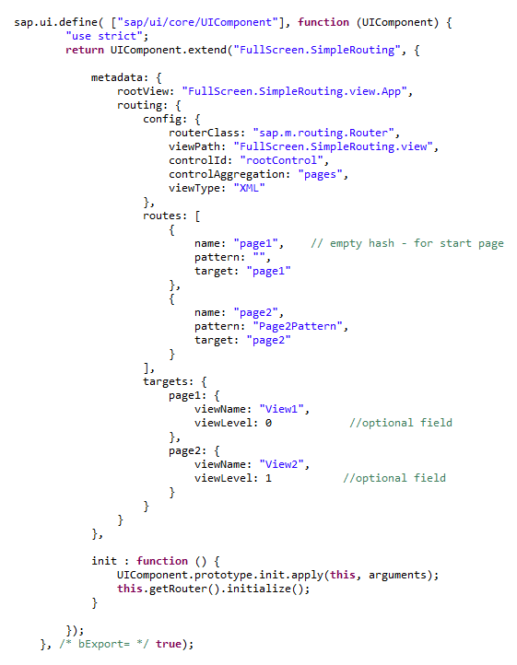

This is component.js file. Routing logic has been written in the metadata section.

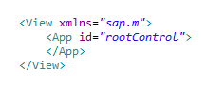

This is app viwe which is the root view of out application.

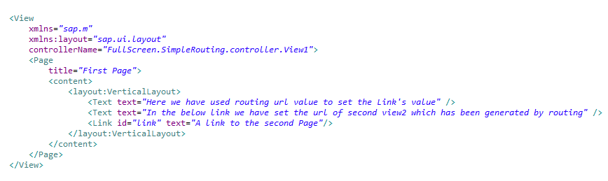

This is the first view. As you can see we have taken the Link control here.

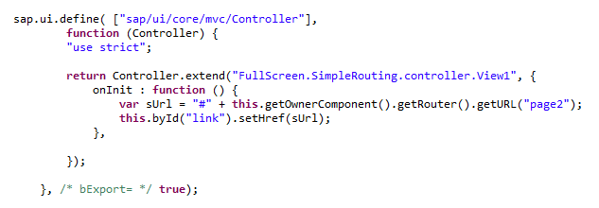

This is the controller of first view. In the onInit function it will get the URL of the second view which is generated by routing and set it to the 'Href' property of the Link control.

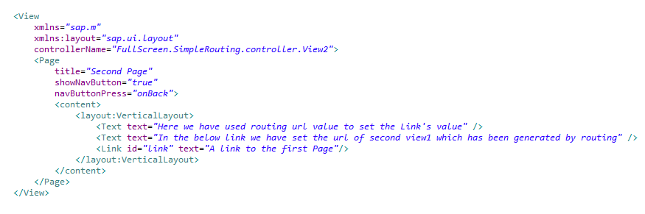

This is the second view. As you can see we have taken the Link control here.

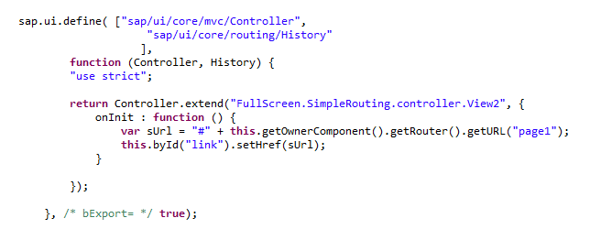

This is the controller of second view. In the onInit function it will get the URL of the second view which is generated by routing and set it to the 'Href' property of the Link control.

[Browser Output](http://www.fioritutorials.com/sapui5-practical-navigation-and-routing/sapui5-routing-with-link.html#collapseFour)

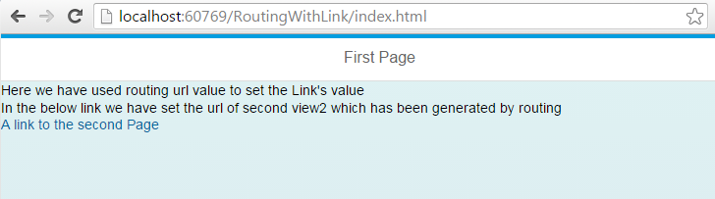

This is the browser output when it initially load the application on browser. As you can see there is not patten in the URL area. When you click this Link it will navigate to second view.

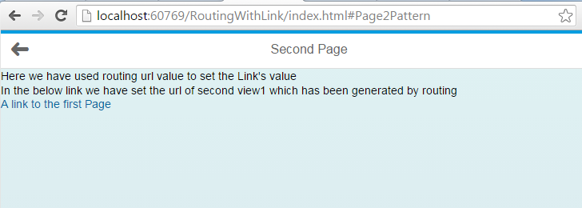

This is the second view on browser. As you can see the URL area a pattern 'Page2Pattern' is displaying. Now if you click Navigation button or on the Link it will navigate to first page.

**Routing with Manifest.json:-**

We have already seen how to make the application using manifest.js which is the descriptor of the application. Now we will write the routing declaration in the manifest file instead of component file.

[Example](http://www.fioritutorials.com/sapui5-practical-navigation-and-routing/sapui5-routing-in-manifest.html#collapseThree)

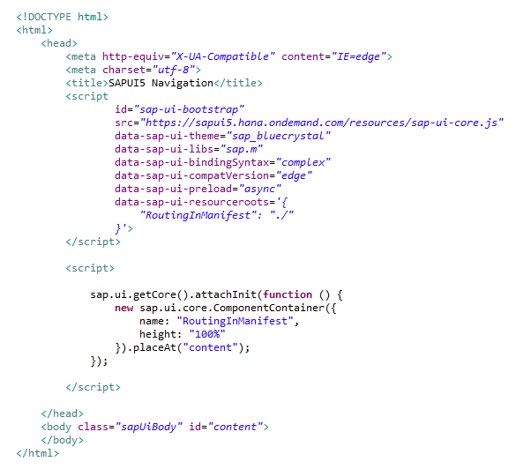

This is index.html. The ComponentContainer will initiates the component.js file.

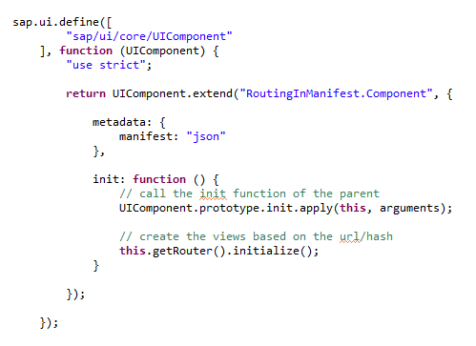

This is component file. As you can see we have removed the routing declaration from here and from metadata section we have load the manifest.

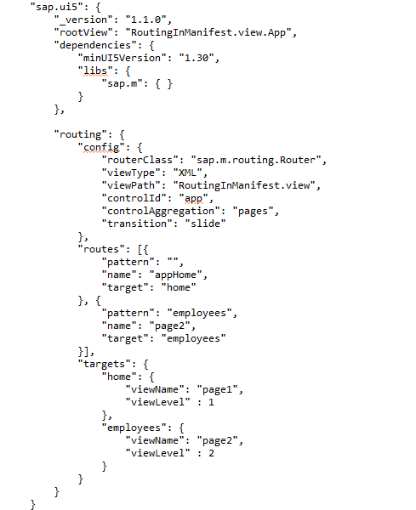

This is the "sap.ui5" section of manifest file. As you can see routing declaration has been written here.

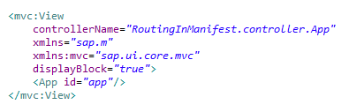

This is app view which is the root view of out application.

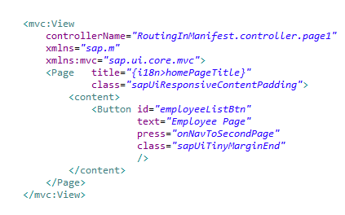

This is the first view. As you can see we have taken the a Button control here.

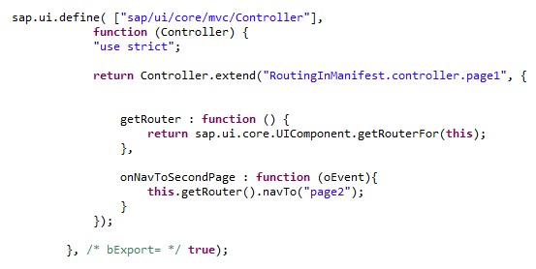

This is the controller of first view. by clicking the button it will call to onNavToSecondPage function and it will navigate to second page.

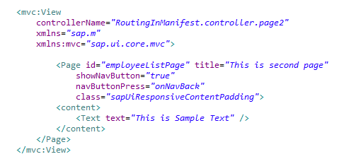

This is the second view.

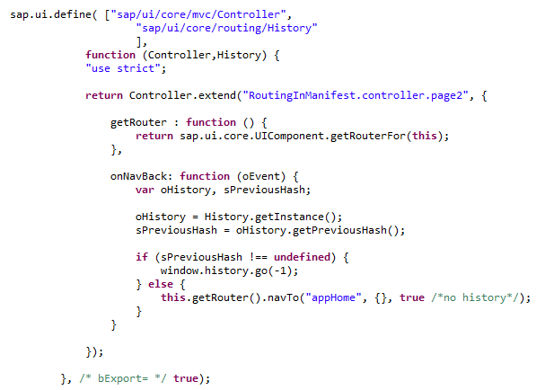

This is the controller of second view. By clicking the navigation button it will call onNavBack.

[Browser Output](http://www.fioritutorials.com/sapui5-practical-navigation-and-routing/sapui5-routing-in-manifest.html#collapseFour)

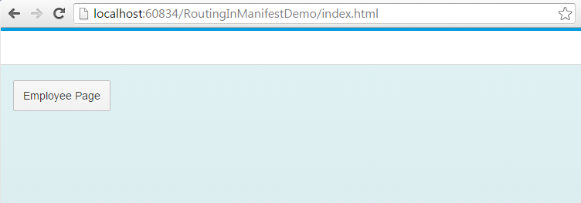

This is the browser output when it initially load the application on browser. As you can see there is no patten in the URL area. When you click this Button it will navigate to second view.

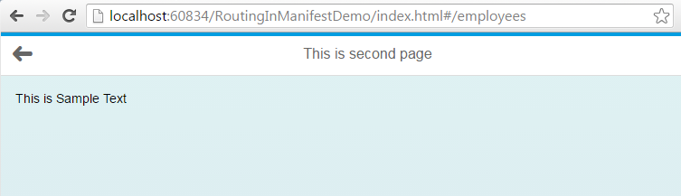

This is the second view on browser. As you can see the URL area a pattern 'employee' is displaying. Now if you click Navigation button it will navigate to first page.

**Routing with scfld library:-**

# **SAPUI5 Routing with SCFLD Library**

#### [How to achieve routing using scfld class?](http://www.fioritutorials.com/sapui5-practical-navigation-and-routing/sapui5-routing-with-scfld-library.html#collapseOne)

When you are using scfld library to build the application the routing declaration is little bit different. Let's see how we can achieve routing using scfld library. Here we have taken the standard application structure for scfld class.

#### [Example](http://www.fioritutorials.com/sapui5-practical-navigation-and-routing/sapui5-routing-with-scfld-library.html#collapseThree)

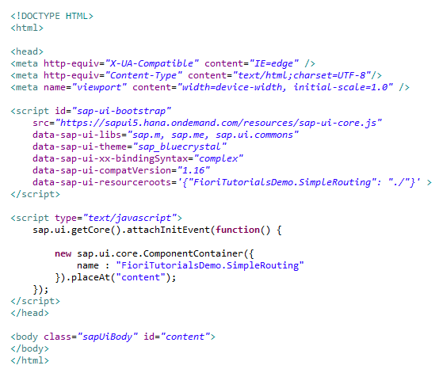

This is index.html. The ComponentContainer will initiates the component.js file.

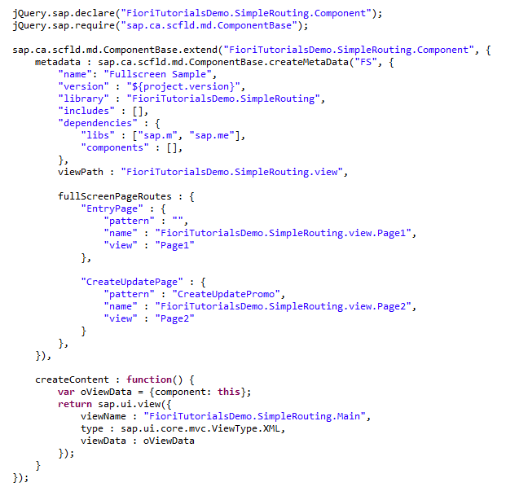

This is component file. The routing declaration has been written in the metadata section.

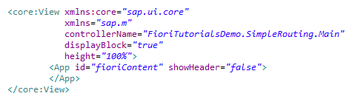

This is Main view which is the root view of out application.

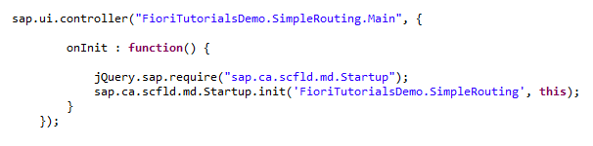

This is the controller of Main view.

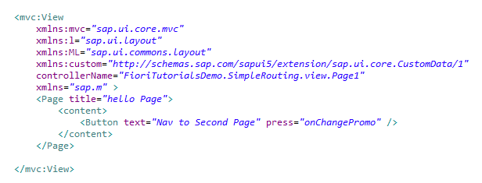

This is the first view. As you can see we have taken the a Button control here.

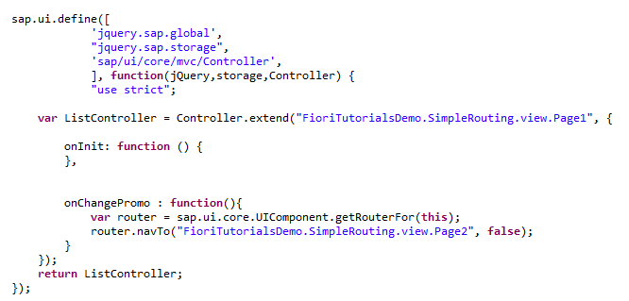

This is the controller of first view. by clicking the button it will call to onChangePromo function and it will navigate to second page.

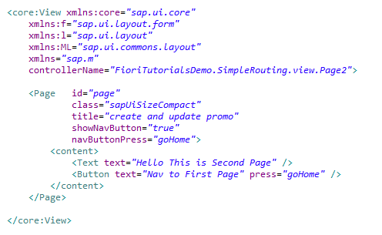

This is second view. Here also we have defined a button which will call 'goHome' fuction which navigate back to first view.

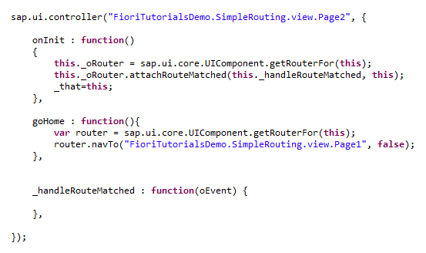

This is the controller of second view. By clicking the navigation button it will call goHome.

# **SAPUI5 Routing with Mandatory Parameter**

#### [Passing the parameter with Routing.](http://www.fioritutorials.com/sapui5-practical-navigation-and-routing/sapui5-routing-with-mandatory-parameter.html#collapseOne)

There are conditions when you want navigate from one view to other view and the same time you want to pass the parameter from one view to another view. This can be achieve using routing.

#### [Example](http://www.fioritutorials.com/sapui5-practical-navigation-and-routing/sapui5-routing-with-mandatory-parameter.html#collapseThree)

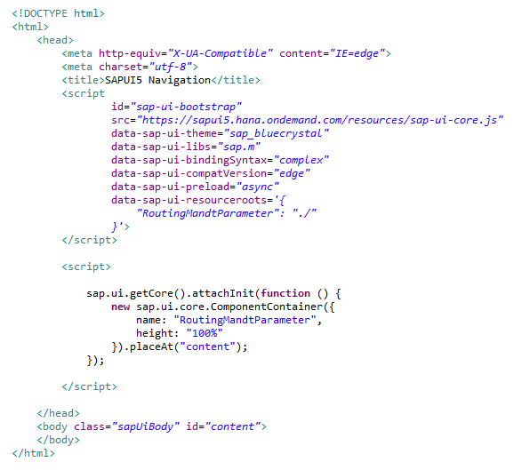

This is index.html. The ComponentContainer will initiates the component.js file.

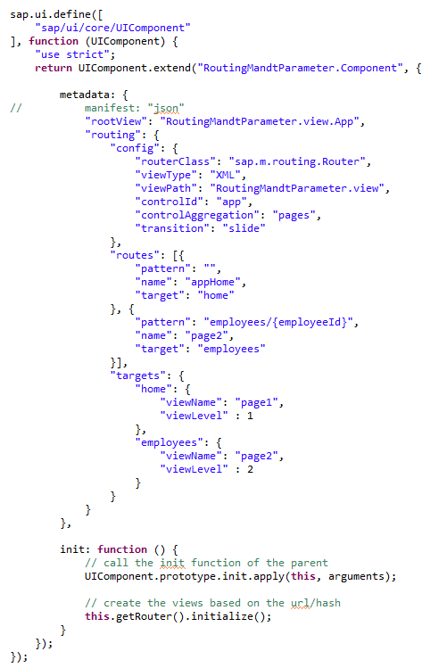

This is component file. The routing declaration has been written in the metadata section.

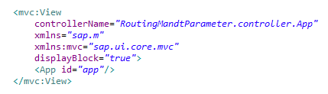

This is app view which is the root view of out application.

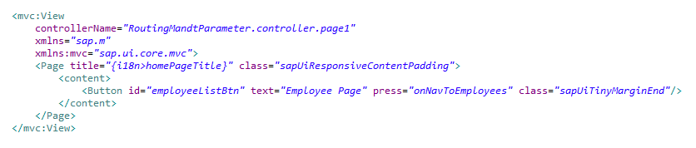

This is the first view. As you can see we have taken the a Button control here.

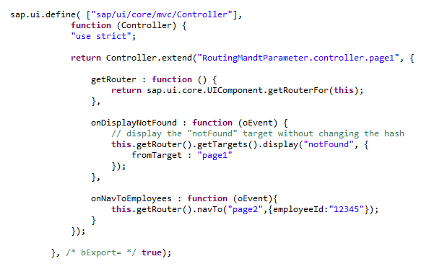

This is the controller of first view. by clicking the button it will navigate to second page.

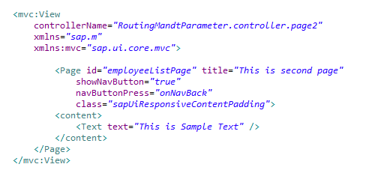

This is second view.

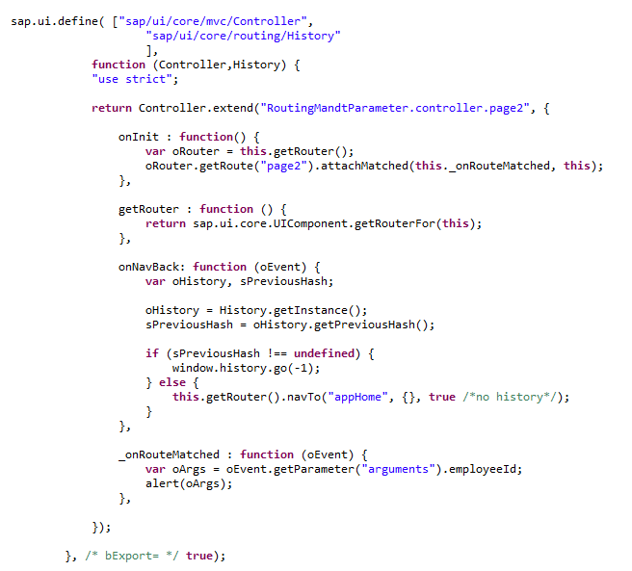

This is the controller of second view. By clicking the navigation button it navigate to first page.

# **SAPUI5 Routing with Optional Parameter**

#### [How create routing with Optional parameter?](http://www.fioritutorials.com/sapui5-practical-navigation-and-routing/sapui5-routing-with-optional-parameter.html#collapseOne)

There are conditions when you want navigate from one view to other view and the same time you want to pass the parameter from one view to another view. Also this parameter should be optional. This can be achieve using routing.

#### [Example](http://www.fioritutorials.com/sapui5-practical-navigation-and-routing/sapui5-routing-with-optional-parameter.html#collapseThree)

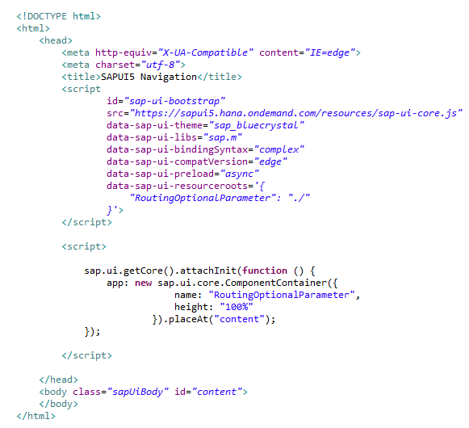

This is index.html. The ComponentContainer will initiates the component.js file.

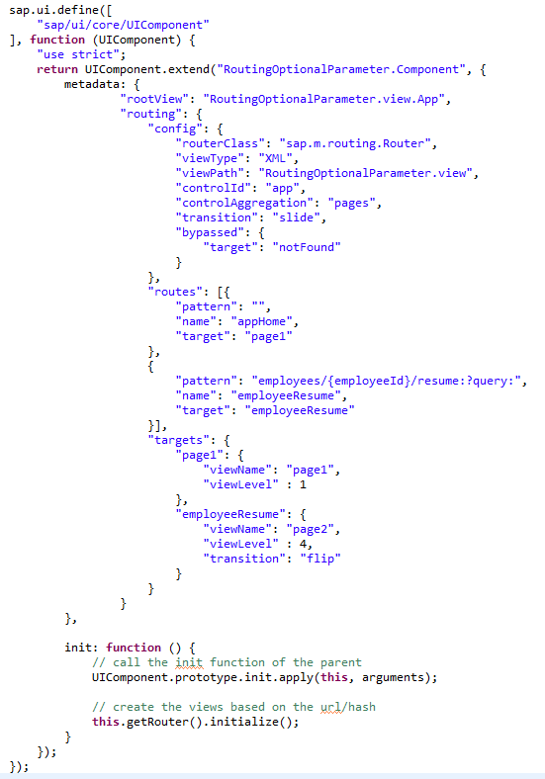

This is component file. The routing declaration has been written in the metadata section.

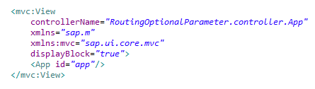

This is app view which is the root view of out application.

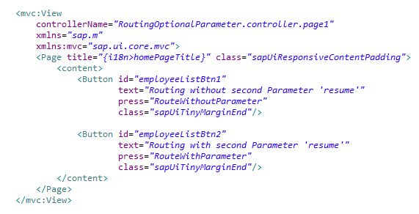

This is the first view. As you can see here we have taken a Button to navigate to second view.

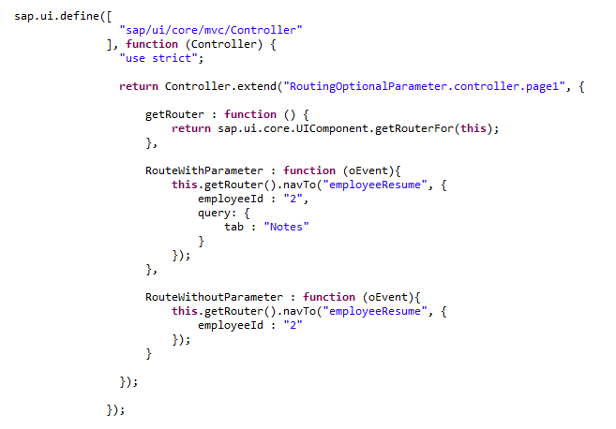

This is the controller of first view. The 'RoutingWithParameter' function will navigate with parameter value. while 'RoutingWithoutParameter' will navigate without parameter passing.

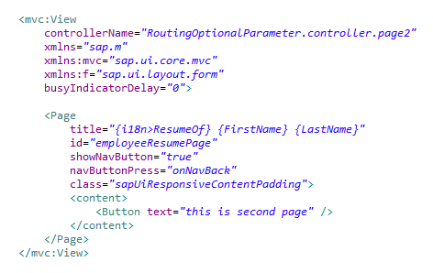

This is second view.

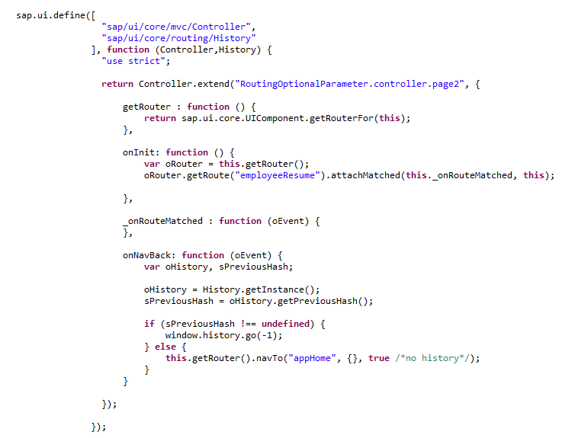

This is the controller of second view. By clicking the navigation button it navigate to first page.

# **SAPUI5 Routing with Multiple Target**

#### [Create Route with Multiple Target](http://www.fioritutorials.com/sapui5-practical-navigation-and-routing/sapui5-routing-with-multiple-target.html#collapseOne)

When we create routing we define target for each route. There are condition when you want to call multiple target from one route OR in other way you want to load two's view content in single view. This can be achieve as follows.

#### [Example](http://www.fioritutorials.com/sapui5-practical-navigation-and-routing/sapui5-routing-with-multiple-target.html#collapseThree)

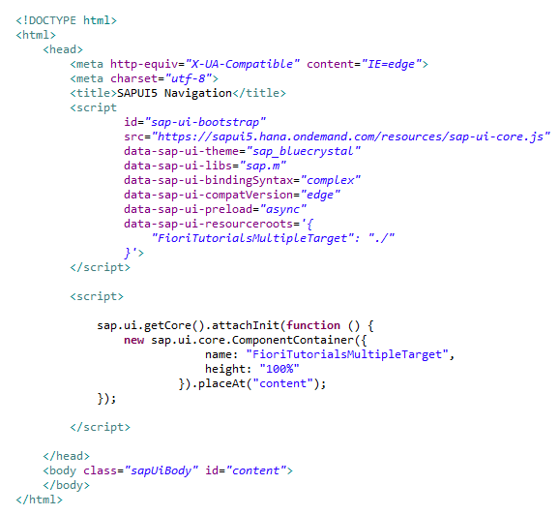

This is index.html. The ComponentContainer will initiates the component.js file.

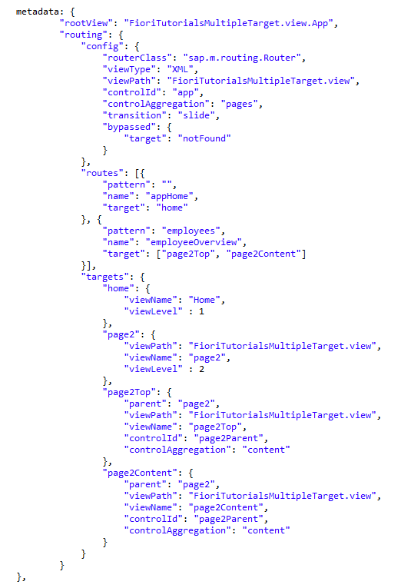

This is component file. The routing declaration has been written in the metadata section.

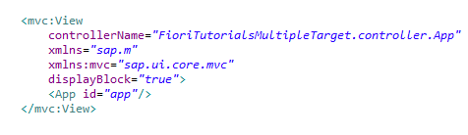

This is app view which is the root view of out application.

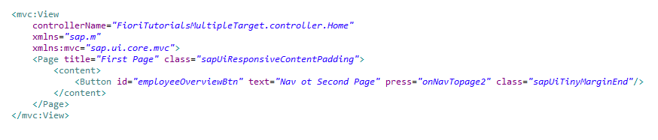

This is the first view. As you can see here we have taken a button to navigate to second page.

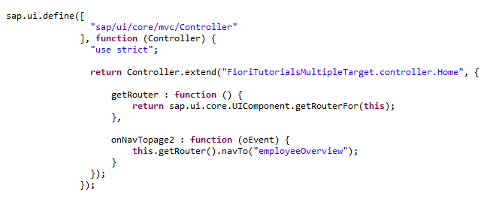

This is the controller of first view. By clicking the button it will call the onNavPage2 function.

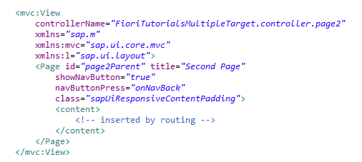

This is second view. As you cann see content area of page is kept empty where we will load the content by routing.

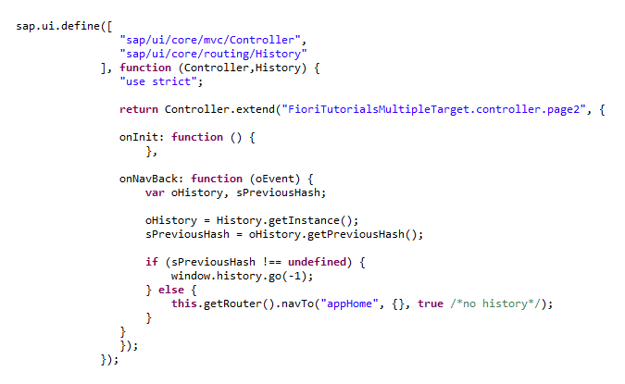

This is the controller of second view. By clicking the navigation button it navigate to first page.

# **SAPUI5 Routing to Page Not Found**

#### [Create Routing for 'Page Not Found' view](http://www.fioritutorials.com/sapui5-practical-navigation-and-routing/sapui5-routing-to-no-found-page.html#collapseOne)

We can create a separate view for all the target views which are not exist. This can be done as follows.

#### [Example](http://www.fioritutorials.com/sapui5-practical-navigation-and-routing/sapui5-routing-to-no-found-page.html#collapseThree)

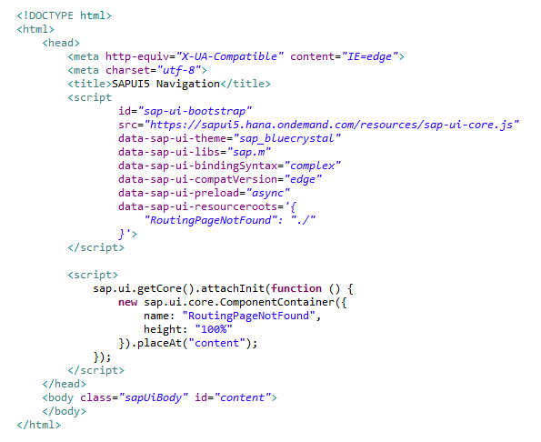

This is index.html. The ComponentContainer will initiates the component.js file.

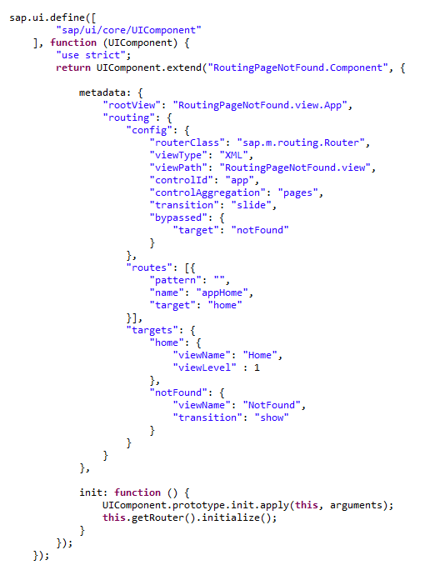

This is component file. The routing declaration has been written in the metadata section.

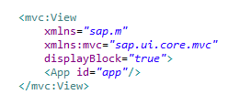

This is app view which is the root view of out application.

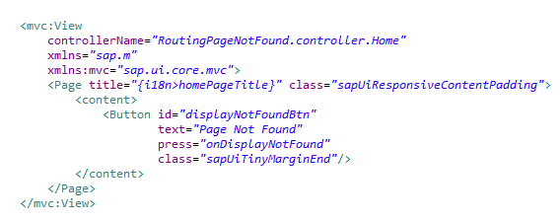

This is the first view. As you can see here we have taken a button to navigate to No Found View.

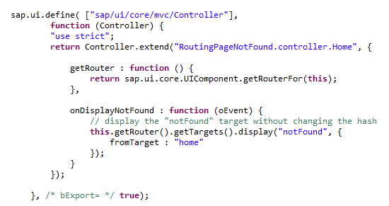

This is the controller of first view. By clicking the button it will call the onDisplayNotFound function.

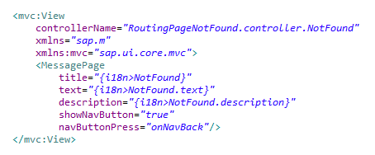

This is second view with the message that 'No view has been found'.

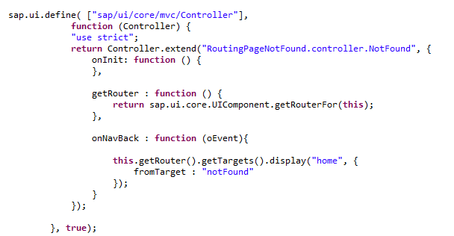

This is the controller of second view. By clicking the navigation button it navigate to first page.

# **SAPUI5 Target without Router**

#### [Create Target with out Router.](http://www.fioritutorials.com/sapui5-practical-navigation-and-routing/sapui5-target-without-router.html#collapseOne)

See the example below.

#### [Example](http://www.fioritutorials.com/sapui5-practical-navigation-and-routing/sapui5-target-without-router.html#collapseThree)

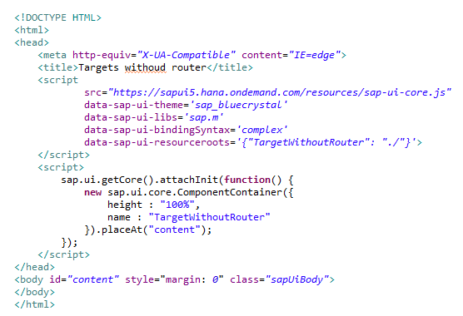

This is index.html. The ComponentContainer will initiates the component.js file.

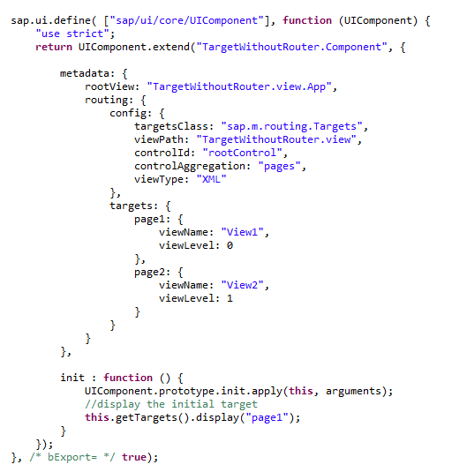

This is component file. The routing declaration has been written in the metadata section.

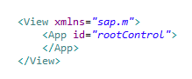

This is app view which is the root view of out application.

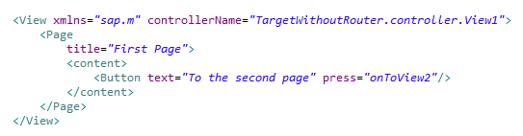

This is the first view.

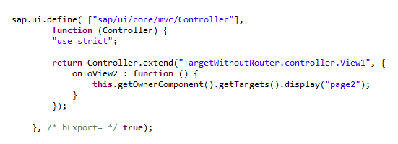

This is the controller of first view.

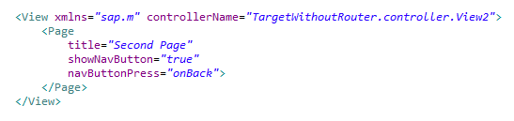

This is second view.

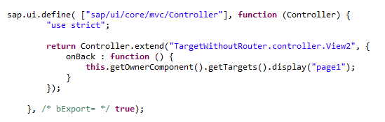

This is the controller of second view.